**Spanos Elementary School**

**Bathroom Guidelines for Success**

|  |  |  |
| --- | --- | --- |
| Be Present | Be Safe | Be Kind |
| 1. Use level 1   voice   1. 2-4-minute trip 2. Honor other’s personal space. 3. Ask permission | 1. Do your business and leave. 2. Flush the toilet 3. Leave no trace of your visit. 4. Report anything unsafe | 1. Wash hands 2. 2 squirts of soap. 3. 2 paper towels/8 seconds under the dryer. |

Individual Release of students to use the bathroom: Use a sign out/in system to monitor student movement. Recommendation is attached at the end of the document.

Mass release of students: Teacher monitors the movement of students from the Hallway allowing only 4 students at a time to go inside the bathroom.

Expectations for students:

|  |  |  |  |
| --- | --- | --- | --- |
|  | Looks Like |  | Sounds Like |
|  | * 2-4-minute trip * Do your business and return to class * 2 squirts of soap. * Honor other’s personal space * Students will ask permission to leave for the bathroom and utilize the sign out/in procedure * See Something—Say Something (report right away anything you see that is inappropriate or unsafe) |  | * Students Flushing the toilet * Students using two paper towels to dry their hands * Students using the dryer for 8 seconds to dry their hands * REMINDER: Go, Flush, Wash, and Leave |

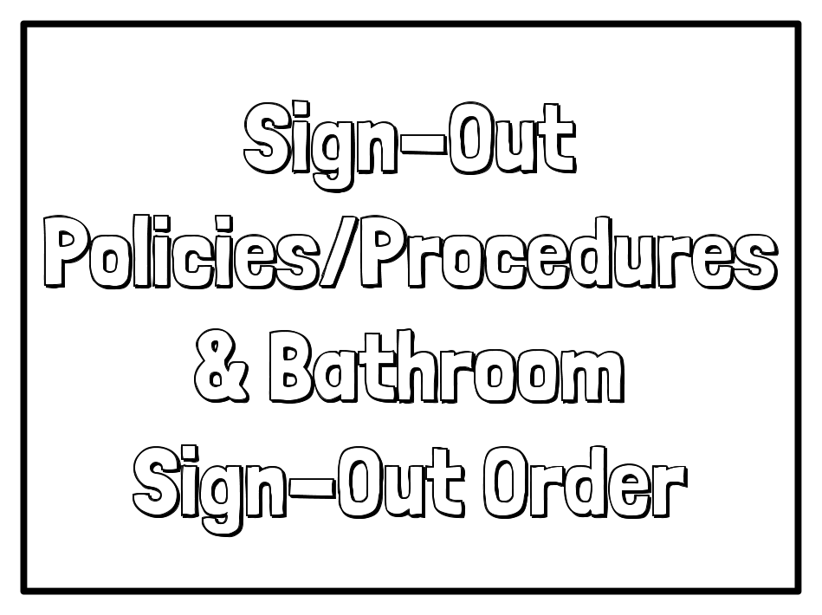

**Room Sign-Out Policies/Procedures 1st-8th grades**

1. Ask Permission to use the bathroom. Use a procedure established within your classroom.
2. It is your responsibility to **use sound judgment to minimize the loss of your valuable instructional time; if possible, avoid leaving the room during whole-class instruction**.
3. **Four to six minutes** is more than enough time to use the bathroom. **More than six minutes out of the classroom is unacceptable** (that’s more than 10% of our class period!) and will result in disciplinary action.
4. Because **only one student at a time** may be signed out to use the bathroom, we use the “take a number” system in this room. Use the number *I’m next!* grid below.
5. Always **sign out/in accurately** and take **the appropriate pass** when leaving the room. Signing out/in and carrying a pass are important safety measures.
6. If you are signed out to use the bathroom, the expectation is that you **walk directly to and from the bathroom.** If you are caught wandering elsewhere, taking the longest route, or otherwise misusing your time out of the classroom, please expect the following **handbook consequences for misusing class time:** 
   1. First offense: teacher detention
   2. Second offense: Recess detention
   3. Third offense: Referral, parent contact and/or detention after school

